Mathematics
National 5
Paper 1
CALL Scotland
Edinburgh
Paul
Nisbet

000000000*

ENTER QUESTION NUMBER BELOW | Do not type in this shaded box | DO NOT WRITE  IN THIS MARGIN
1
2
3
4
5
6a
6b
7a
7b
8
9a
9b | 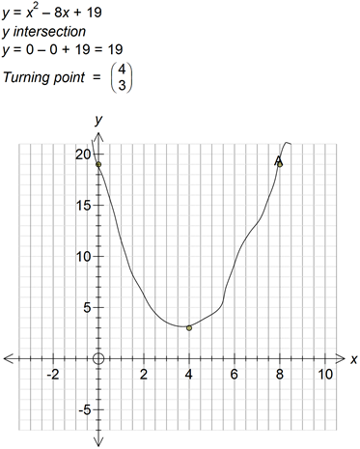
10a | 3f + 4r = £185
10b | 2f + 3r = £130
10c | $$3f+4r=185 \\ 2f+3r=130 \\ f=\frac{130-3r}{2} \\ 3\frac{130-3r}{2}+4r=185 \\ 195-\frac{9}{2}r+4r=185 \\ -\frac{9}{2}r+\frac{8}{2}r=185-195 \\ -\frac{r}{2}= -10 \\ r=20$$
11
12a | X = r - 5
12b

For Marker’s Use

Question No | Marks/Grades

